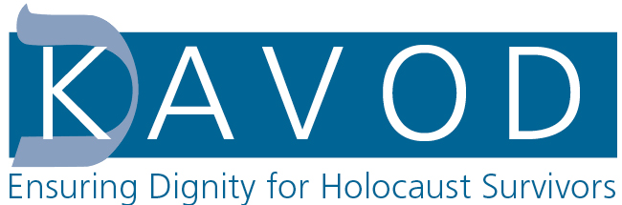

KAVOD SHEF Program Coordinator – Independent Contractor – Part Time

KAVOD, Ensuring Dignity for Holocaust Survivors, seeks an organized, self-motivated, and self-directed individual. Candidates should have a Bachelor’s degree, excellent administrative, organizational, and communications skills, and be well versed in Microsoft Excel, Quickbooks, and/or Smartsheets. Candidates should have an understanding of tracking data and basic bookkeeping and/or accounting. Additional skills include the capacity for self-direction, effective time management, and multitasking. Attention to detail and the ability to communicate with partner organizations and individuals by phone and email are essential. The KAVOD SHEF Program Coordinator will report to and work closely with the Projects and Administrative Manager.

Candidates must have a home office or workspace, laptop, printer, and other office equipment. This is an independent contractor position.

Duties will include but not be limited to:
- Processing requests by purchasing gift cards and paying providers directly for Holocaust Survivor clients.
- Communicating regularly with local partner agencies on Survivor needs and requests.
- Communicating with service providers.
- Tracking data on a Smartsheets system (similar to Excel)
- Entering expenses and vendor details in Quickbooks
- Maintaining the integrity and level of service that KAVOD has been known for having since its inception.
- Work closely with the Managing Director of KAVOD SHEF and the Projects and Administrative Manager to successfully manage this project.

Due to the emergency nature of our work, candidates must commit to fulfilling all requests within the 7-day guidelines of our grant. Responsiveness is essential and the project is time sensitive.

Compensation:
$28 an hour: 20-30 hours a week on average
Estimated start date January 6, 2025

